Meta Description:
Find reliable bathroom remodelers in Houston with our guide. Learn key factors to consider before hiring, from credentials to communication skills.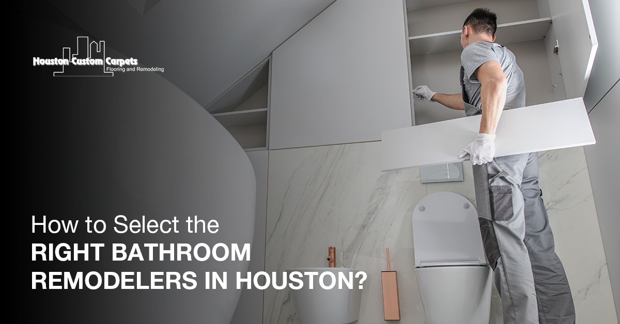

How to Select the Right Bathroom Remodelers in Houston? H1
Whether you are planning for a bathroom overhaul or a simple makeover, getting the right team is possibly the best feat. This guide will provide you with an easy way to select the most suitable bathroom remodelers in Houston that will meet your expectations in your project.

Understand Your Vision H2
When you are going to select any bathroom remodelers in Houston, you must have a precise idea of what you want. You can consider factors like style, functional aspects, and cost to identify the right remodelers. You can ask yourself questions like:
Do you want your bathroom to be a traditional and comfortable one? Is it the need for additional space for storage or may be a special desire to have a walk-in shower?
Fixed goals will enable you to express your requirements more briefly to the remodeler candidates you intend to hire.

Research Local Remodelers H2
You should begin by searching for bathroom remodelers in your local closets in Houston. You can rely on Directory listing, web search, and review sites to get a list of prospective candidates.
Other web services such as Houzz, Angie’s List, and Yelp can be helpful in the preparation for the contractor interview to get an impression of what their previous clients have to say about them.
Always select those remodelers, who have good online representation and positive feedback.

Check Credentials and Experience H2
After the compilation of a list of remodelers, you need to check on their authenticity. Make sure you check their license, insurance, and bond papers.
Ensure your selected remodelers also provide a cover in case of an accident or any disaster while undertaking the renovations. Getting bonded effectively assists in the guaranteeing of the project’s completion.

Experience is another crucial factor. Search for contractors that have experience in bathroom remodeling services.
You should check different pictures and works that can be found in the portfolio section of their profiles.
Check how intricate and elaborate the works they have done, and how and in what manner they were designed.
Professional remodelers will always have a better appreciation of inconveniences that may arise in the process of reformation that they are undertaking.

Seek Recommendations H2
A personal referral is one of the most effective forms of advertising that can be received by a person. Still, most people that you know, be it friends, members of your family, or your neighbors, would be willing to give tips about the best bathroom remodelers.
These people can share first-hand experiences of what they have undergone with different remodelers. Also, you should consider asking for advice from other contractors or designers that are within your region.

Schedule Consultations H2
After that, it is time to complete your list of prospects and set a meeting with the most suitable candidates.
This is a good chance to get to know the remodelers themselves. Here you can notice aspects like the way they handle themselves and the explanations they give you.
Before going to select any remodeler, make sure you have prepared a list of questions to ask.
Ask them about the procedures, the time they take to complete the project, and payment terms to be made. Based on these criteria, consider your vision and price and assess their reactions.
While communicating with a good remodeler, you can hear everything that they have to say and get some feedback from them.

Evaluate Communication Skills H3
As with any other project, communication plays an important role in how a bathroom remodel is going to turn out.
While consulting the remodeler, you should try and check the communication skills of the remodeler.
Alternatively, do they assess their client’s needs effectively by listening to your questions and proactively answering them in an explicit and precise manner?
Is the task provider patient and able to answer all your questions or discuss the work to be done?
An effective communication remodeler will inform you about the project's progress and avoid such factors as misunderstanding and time loss.

Review Contracts Thoroughly H3
Another important step is to review the contract to identify exactly what your remodeler will do and at what price.
It should cover such sections as work description, time frames, payments, and terms of warranties and guarantees.
Keep all the discussions made and all agreements made in the contract. In any case of doubt, you should ask a question before continuing.
Reporting progress ensures conscientious management of a project and provides both parties with specific expectations to be observed throughout the project.

Plan for the Unexpected H3
During removing a bathroom you may discover plumbing and other structural issues in the room. Finally, ask your remodeler to explain how they deal without major complications.
With these situations in mind, a reputable remodeler will always have strategy adaption mechanisms in mind. Also, add a relevant clause that deals with additional costs and other alterations that may be required.

Prioritize Sustainability H3
If you care about the environment, it is relevant to ensure that the remodeler used is environmentally friendly.
You can ask about the materials used and for using lighting that is energy efficient or environmentally friendly.
The right remodelers can give choices like energy-efficient faucets and pipes, low-flow toilets, energy-efficient lighting, and the use of recycled more.
Select a remodeler who is environmentally conscious because this will help in the reduction of the general impact on the environment as well as cheap electricity bills.

Ensure a Smooth Transition H3
Plan for the transition before the renovation is carried out. Always try to know how the remodeler is going to control dust and debris, and how long the work will take If the bathroom will be your primary area.
Understanding and sharing information with everyone concerned about the renovation process will go a long way in avoiding as much disruption to his daily life or planned activities.

Stay Involved H3
It is good to work with a remodeler who can be trusted but does not completely leave the project in their hands, and it is wise to monitor it all the time.
Monitor their work progress often and then respond to any challenges early enough. It often becomes okay to ask questions or request more information when you are confused with information or information given creating doubt in your understanding.
This makes sure that the project is lively and that you can achieve what you want in that particular project.

Trust Your Instincts H3
Finally, trust your instincts. In case you find something awkward about a remodeler, it is expressly proper to change the decision.
You can trust your instinct when it comes to your bathroom renovation because it will tell you whether or not you can trust that particular person.
Select the remodeler with whom a good working relationship is necessary because this is an important ingredient in the remodeler’s or renovator’s work area.

Final Thoughts H3
It is very important in Houston to approach a bathroom remodeler carefully.
When you understand your vision, knowing all the local options, checking for credentials, gathering information on team’s communication skills, you can easily identify the right team.
Read over documents carefully, including contracts, be ready for mortgage shocks, and always have sustainability as a goal.
Remodeling your home requires you to use your best judgment and go for the remodelers whom you are comfortable with.
At Houston Custom Carpets, we are willing to assist you in any of your bathroom remodeling project. Get in touch with us to know more on how we can offer you the best solution in your bathroom remodeling project.

GMB
Transforming your bathroom starts with finding the right remodeling team in Houston. At Houston Custom Carpets, we guide homeowners through the essential steps of bathroom renovation success. You should sit down and determine which style you want for your shower, whether you want it traditional, where it only has a bathtub and a shower head, a shower with additional storage, or a luxurious walk-in shower. As with any business, ensure you check with the authorities whether they are legal, licensed, and insured. Our staff has undergone many years of bathroom remodeling practice in the region. While interacting with potential contractors, pay attention to the way they speak, address questions, and listen attentively. It is, therefor,e necessary that both parties agree on a time frame for delivery and cost estimat,e including any payment plan and warranties. So, identify the right contractor that values work and focuses more on sustainable practices such as effective lamps and green products that will help to minimize the impact on the environment as well as the costs of electricity. Though it is good to rely on the contractor, it is always good to be as involved as possible to see your idea turn into real life. At Houston Custom Carpets, we listen to the client and involve them in the decision-making process throughout the carpet purchasing process. Contact Houston Custom Carpets today for a bathroom transformation that exceeds your expectations.

